  - Miracles for Vets

Service application Motorsports
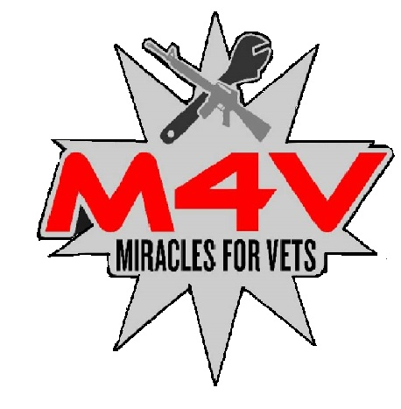
Miracles for Vets, application process requires a credit score (may be obtained free through Credit agencies full credit report is not needed), proof of service (DD-214 or other official documentation) and a written statement for “why” the request is being made including the impact that approval or denial may have on the Veteran’s quality of life.

current employment
Title |  | Start Date
Company name |  | Please select reason of request, for other please specify | primary transportation
Phone | Fax |  |  | work needs
E-mail |  |  | disability accommodation
Company address  City, State ZIP Code |  |  | Other

military service information
Branch of service |  | Rank at discharge/ retirement
Disability rating |  | Entry/ exit dates (MM/YY-MM/YY)

personal/ proffesional REFERENCES
Name |  | Relationship
Address |  | Phone
City, State ZIP Code |  | E-mail
Name |  | Relationship
Address |  | Phone
City, State ZIP Code |  | E-mail
Company name |  | Relationship
Address |  | Phone
City, State ZIP Code |  | E-mail

agreement
- Request is subject to availability and needs.
- Miracles for Vets may use provided information in contact with partnering organizations to supply necessary/ reasonable requests.
- By submitting this application, you authorize Miracles for Vets to make inquiries into the references that you have supplied.
- Insurance and other related expenses are responsibility of the owner as applicable by state law.
- Vehicles received and donated are “AS IS” and Miracles for Vets does not imply or guarantee any warranty.
- Miracles for Vets does NOT guarantee acceptance of all applications nor has implied doing so.
- Acceptance does not guarantee delivery of any item(s)
- Miracles for Vets does not promise transfer if title and fees associated with transfer of ownership of a vehicle to be covered, recipient MAY need to cover costs out of pocket.
- Send completed application to M4Vboss@gmail.com or by mail Miracles for Vets 1115 26th AVE S #8 Grand Forks, North Dakota 58275

SIGNATURES
Name |  | Signature
Address |  | Name
City, state, zip |  | Date

